**PROPERTIES OF CONTINUOUS**

**TIME FOURIER SERIES**

**LAB # 11**



**Spring 2023**

**CSE301L Signals & Systems Lab**

Submitted by: **Ali Asghar**

Registration No. : **21PWCSE2059**

Class Section: **C**

“On my honor, as student of University of Engineering and Technology, I have neither given nor received unauthorized assistance on this academic work.”

Submitted to:

**Engr. Sumayyea Salahuddin**

Date:

**June 13, 2023**

**Department of Computer Systems Engineering**

**University of Engineering and Technology, Peshawar**

## Lab Objective(s):

Objectives of this Lab are;

* Properties of CT Fourier Series

1. Linearity
2. Time Shifting
3. Time Scaling
4. Time Reversal

## Task # 01:

Given the signal x(t) with ak’s

1. Plot the time reverse version of the signal x(‐t) directly,
2. Plot FS coefficients a‐k of time reversed signal,
3. Plot the reconstructed time reversed signal using FS coefficients a‐k

Hint: use bk = fliplr(ak); for flipping the ak’

**Problem Analysis:**

To observe fourier properties.

**Algorithm:**

* Write code
* Execute Code
* Record Results

**Output / Graphs / Plots / Results:**

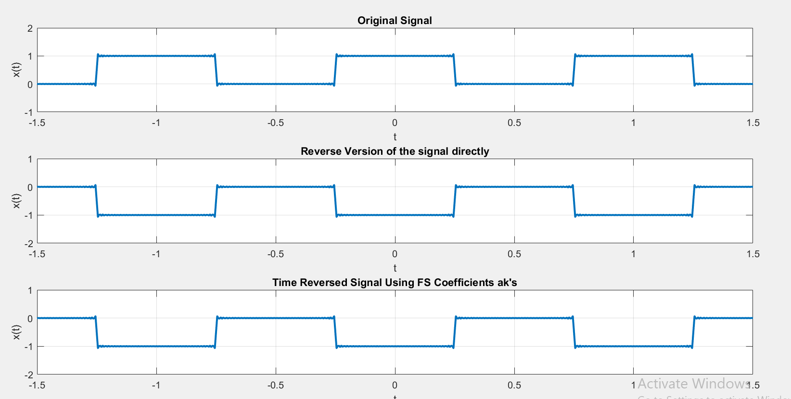

**Discussion and Conclusion:**

We analyzed properties

## Task # 02:

Given the periodic square wave x(t) with T = 1 & T1 = 0.25, rewrite the above code for time scaling when value of alpha is 2 i.e. x(αt) = x(2t).

**Problem Analysis:**

To observe fourier properties.

**Algorithm:**

* Write code
* Execute Code
* Record Results

**Output / Graphs / Plots / Results:**

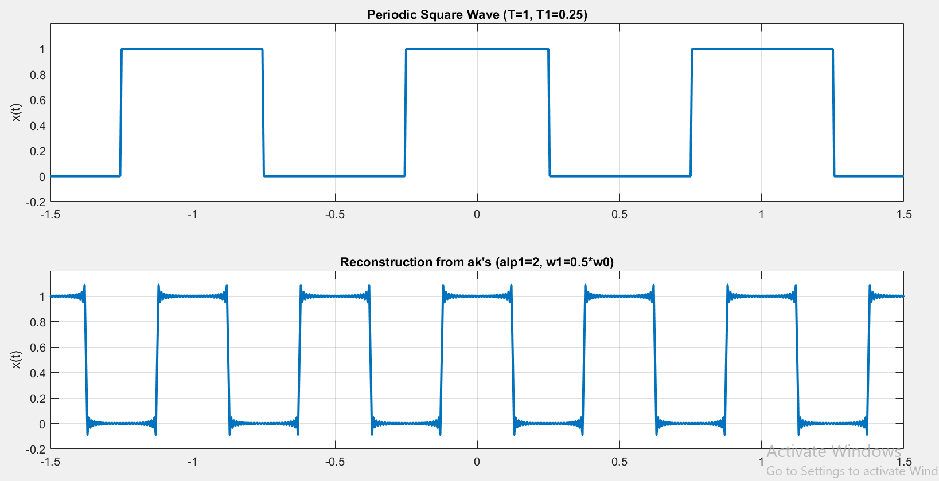

**Discussion and Conclusion:**

In this lab we learnt about the properties of CT Fourier Series i.e. Linearity, Time Scaling, Time Shifting and Time Reversal.